**Documentation for Sri Chaitanya Hospital website**

Website Name: - [**www.chaitanyaorthoeye.com**](http://www.chaitanyaorthoeye.com)  
This technical documentation provides an in-depth understanding of the Sri Chaitanya Hospital web application. Built on top of React, a JavaScript library, and utilizing the React-Bootstrap UI framework, this application serves as a platform to showcase the hospital's services, with a particular emphasis on Ophthalmology and Orthopaedics and spine.

**Table of Contents**  
**1. Technology Stack**  
 1.1 React

1.2 React-Bootstrap

**2. Application Structure**  
 2.1 Components

2.2 Pages

2.3 Routing

**3. Deployment**  
 3.1 GoDaddy Domain Name.  
 3.2 GoDaddy Web Hosting.

4. **Search Engine Optimization**

1. **Technology Stack**
   * 1. **React**

* Version: 18.2.0
* Description: It is a JavaScript library for building user interfaces. It allows for the creation of reusable UI components, making the application modular and efficient.
  + 1. **React-Bootstrap**
* Version: 2.9.1
* Description: React-Bootstrap is a UI framework for React applications. It leverages the Bootstrap library to provide pre-designed components for responsive and aesthetically pleasing user interfaces.

1. **Application Structure**

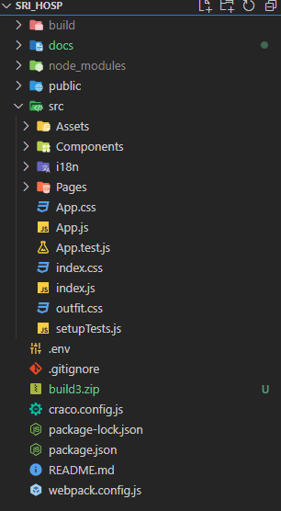

* + 1. **Components**
* The application is structured into reusable components, facilitating modularity and maintainability.
* Components are organized based on their functionality and can be easily integrated into different pages.
  + 1. **Pages**
* Different pages are created for Ophthalmology, Orthopaedics, About Us, and Contact Information.
* Each page utilizes specific components to present relevant information.
  + 1. **Routing**
* React Router is used for client-side routing, ensuring a seamless navigation experience.
* Routes are defined for each page, and navigation is handled without a full page reload.

**3. Deployment**

**Steps for Web Hosting**

* For the deployment process follow the below steps.
* You can find the build folder from the react application by entering the below command in the projects folder location in the terminal.

**npm run build**

* Then, sign in to the **GoDaddy account** and navigate to my products console.
* Under navigate to the webhosting console from there you can find a **cPanel Admin** from the more options and navigate to the File manager where the build files are stored into the **public_html** folder.
* But first, compress the build folder into a zip file and then upload it to the public_html folder.
* After uploading, extract the build file and place it into the public_html folder.
* By following these steps the website will be up and running in the browser.

**Note**: while adding the multiple sites into the public_html folder we need to create a subfolder depending upon the domain name consideration.

**Steps for Domain Name Selection**

* For Registering a domain name, we can select the desired domain name by searching in the domain name console of GoDaddy account.
* There after purchasing the domain name, the GoDaddy itself propagate the DNS records as per the domain name internally.

1. **Search Engine Optimization**

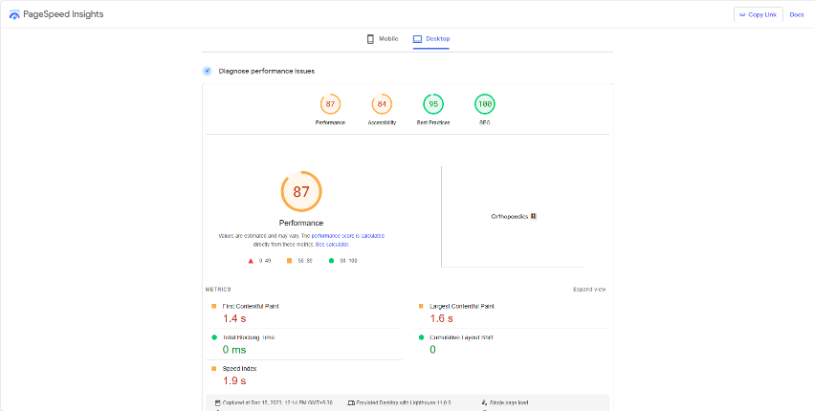

**React Helmet for Dynamic Metadata:**

* One of the challenges in single-page applications (SPAs) is ensuring that search engines receive accurate and dynamic metadata.
* **React Helmet** addresses this by allowing you to dynamically set the title, meta tags, and other crucial SEO elements for each page.
* By customizing metadata, we optimize how your pages appear in search engine results, increasing the likelihood of clicks.

**Sitemaps for Search Engine Crawlers**:

* Sitemaps provide search engine crawlers with a roadmap to navigate through your application's content efficiently.
* By generating and submitting a comprehensive sitemap, you ensure that search engines index all the relevant pages of your React app.
* I have used the Google Search Console to index the pages from the google account of hospital.

**Strategic Keyword Placement:**

* Keywords remain a cornerstone of SEO, and their strategic placement within your React app's content is essential.
* React Helmet allows you to dynamically insert keywords and other metadata on a per-page basis.
* With the help of digital marketing team, we have found some essential keywords for the website which were mostly searched from the users in the google or any other search engines.
* We have added the keywords for every page dynamically for every individual page using React Helmet.

In conclusion, by integrating React Helmet for dynamic metadata, implementing sitemaps for effective crawling, and strategically incorporating keywords, your React app can establish a strong foundation for SEO success. These practices not only enhance your website's visibility but also contribute to a seamless user experience, fostering increased engagement and organic growth.

1. **Contact form Submission**

* To upload the form details from the contact form to book an appointment or for consultation of doctors. I have used EmailJs which was integrated with google account of hospitals Gmail account.
* The contact form details will directly sent to the Gmail account of the organisation through the middleware which is EmaiJs and it is free for 200 mails requests for a month later on the services need to upgrade for more than 200 emails per a day.